GA4 Daily KPIs
GA4 > SQL Server (Medallion) > Power BI
Part I — Report Features, Navigation, and User Experience
GA4 Daily KPIs Dashboard (Overview Page)
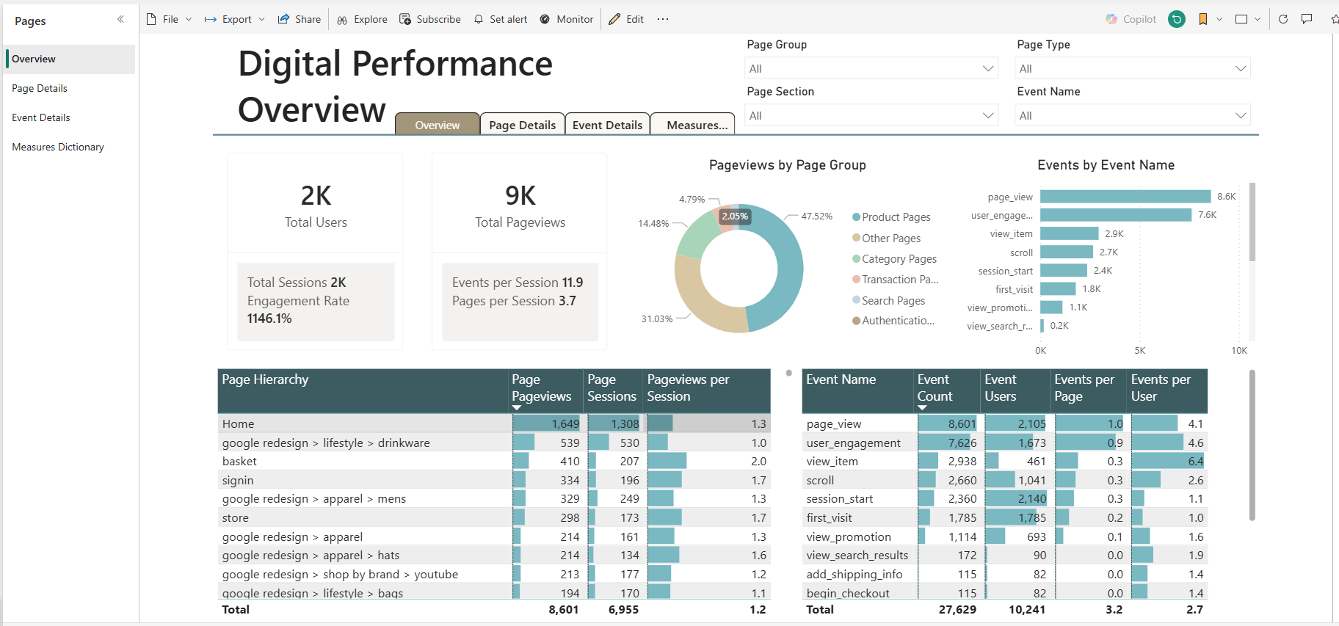
The Digital Performance Overview page provides a one-page summary of website behavior and engagement, sourced from GA4 and modeled through a SQL Server medallion architecture.
KPI cards surface the core web analytics metrics:
- Total Users
- Total Pageviews
- Total Sessions
- Engagement Rate
- Events per Session
- Pages per Session
A supporting donut chart breaks Pageviews by Page Group (Product, Category, Transaction, Search, Authentication, Other), while a bar chart shows Events by Event Name (page_view, user_engagement, view_item, scroll, etc.).
A Page Hierarchy table exposes page-level performance:
- Page Hierarchy (Home, category, product, etc.)
- Page Pageviews
- Page Sessions
- Pageviews per Session
An Event Name table surfaces event-level performance:
- Event Name
- Event Count
- Event Users
- Events per Page
- Events per User
Slicers allow for quick filtering:
- Page Group
- Page Section
- Page Type
- Event Name
Drill Through allows for quick filtering + navigation to either the Page Details or the Event Details pages.
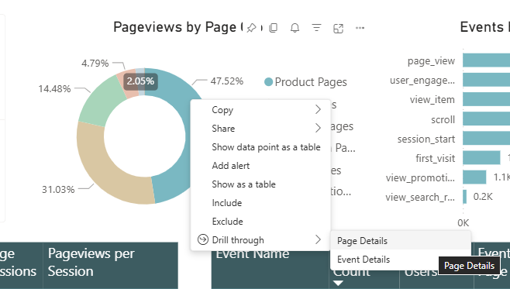

Page Details Page
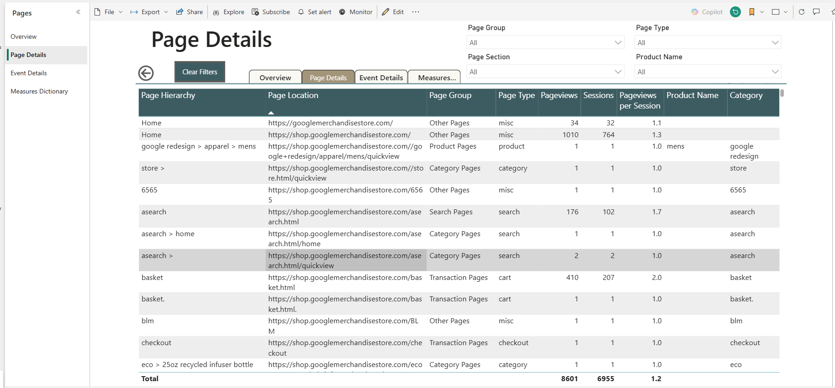

The Page Details page provides a deep drilldown into page-level behavior, including:
- Page Hierarchy
- Page Location
- Page Group
- Page Type (home, category, product, search, transaction, auth, misc)
- Pageviews
- Sessions
- Pageviews per Session
- Product Name
- Category
This page is designed for analysts exploring which sections, categories, and specific pages drive engagement and traffic.

Event Details Page
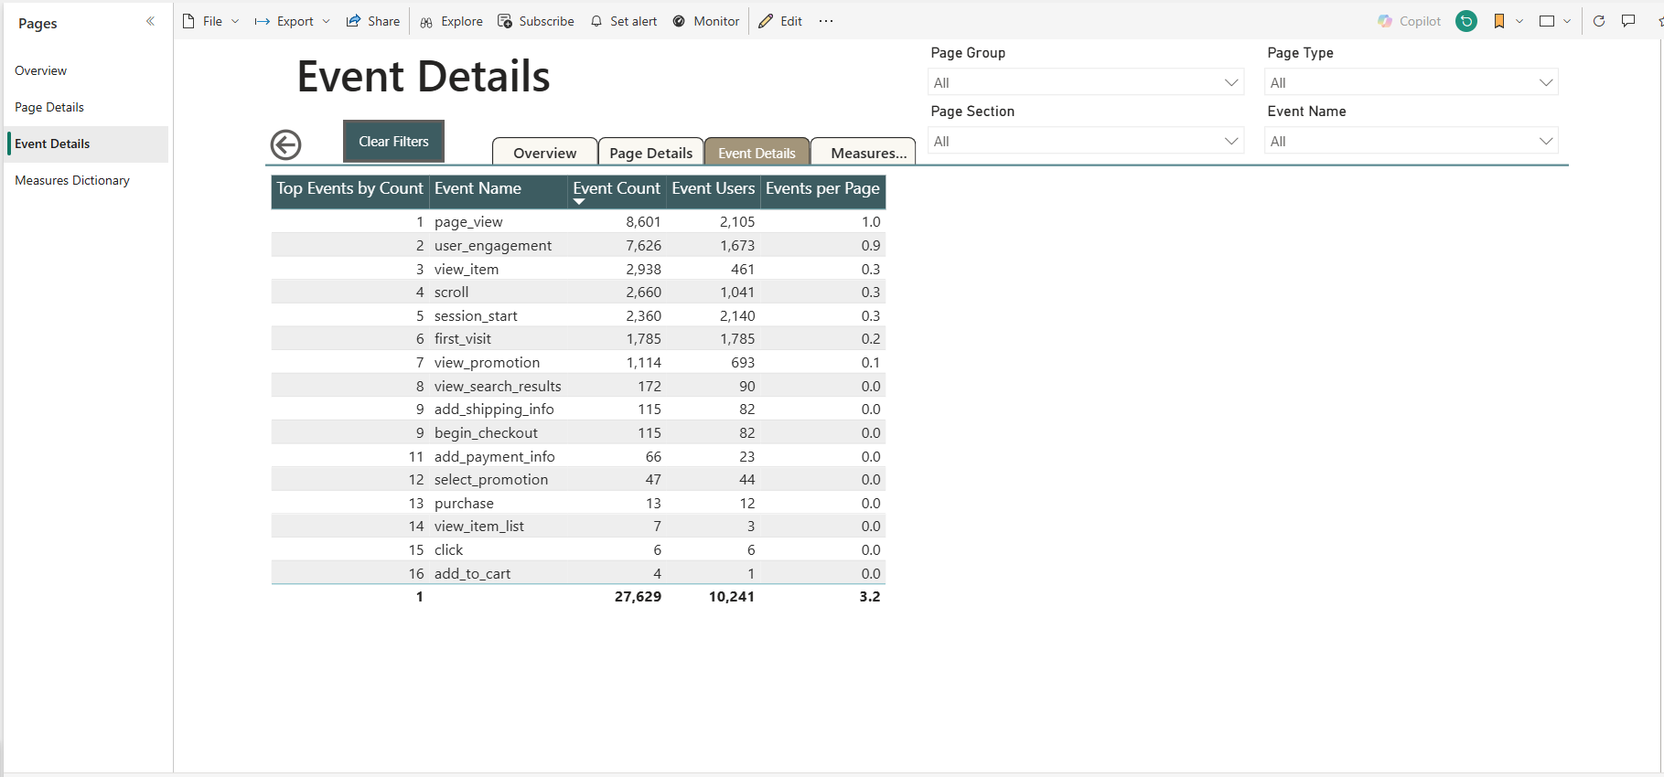

The Event Details page focuses on behavioral events:
- Event Name
- Event Count
- Event Users
- Events per Page
This page is ideal for understanding engagement patterns (scroll, view_item, user_engagement) and conversion-adjacent events (begin_checkout, add_shipping_info, view_search_results).
Slicers
The report includes intuitive slicers aligned to the web analytics domain:
- Page Group (Product, Category, Transaction, Search, Authentication, Other)
- Page Section (top-level site section)
- Page Type (home, category, product, etc.)
- Event Name
These slicers allow users to isolate specific parts of the site and instantly recalculate KPIs, page performance, and event behavior.
Navigation and Drill through
A top navigation bar provides quick access to:
- Digital Performance Overview
- Page Performance Details
- Event Performance Details
- Measures Dictionary
The report supports drill through from the Overview page to:
- Page Details:
  - Right-click a row in the Page Hierarchy table
  - Drill through > Page Performance Details
  - The Page Details page opens filtered to the selected page context
- Event Details:
- Right-click a bar in the Events by Event Name chart or a row in the Event Name table
- Drill through > Event Performance Details
- The Event Details page opens filtered to the selected event context
A dedicated Clear Filters button resets drill through filters on the detail pages, and a Back button returns the user to the Overview page while preserving context.

Measures Dictionary Page
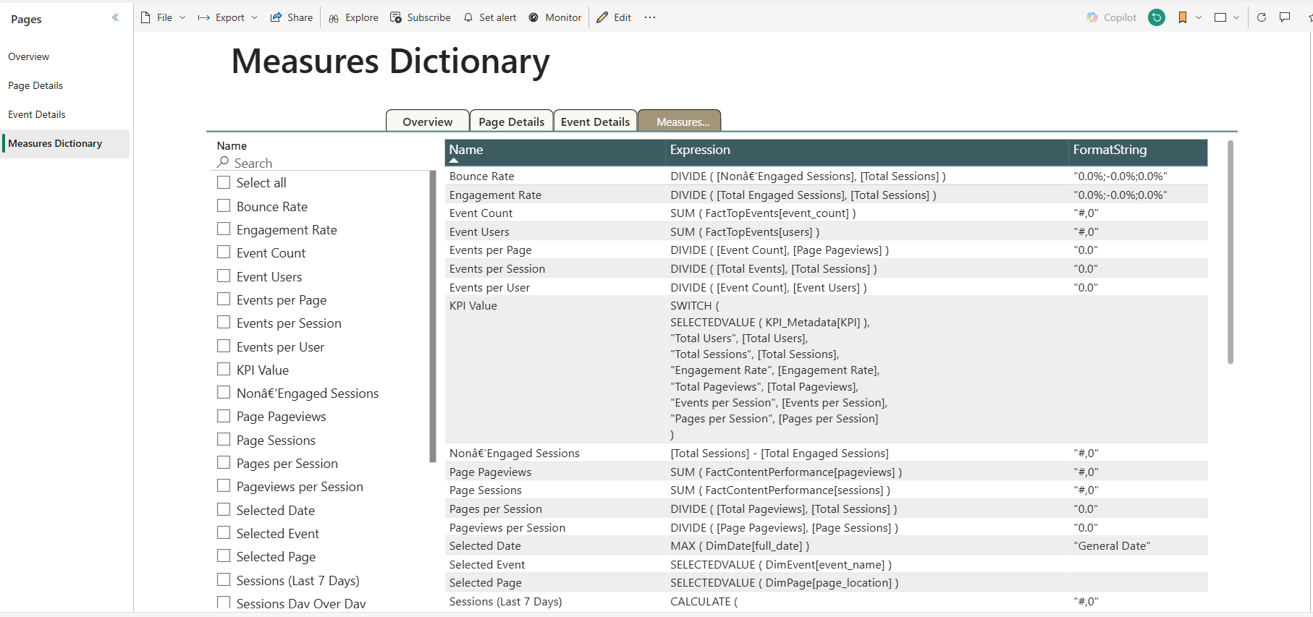

The Measures Dictionary page documents the semantic layer behind the GA4 Daily KPIs report. It includes:
- Measure Name
- DAX Expression
- Format String
- Calculation Logic / Description
This page is essential for transparency, auditability, and future extensibility.
The Measures Dictionary table is populated using:
- DAX query (same pattern as prior project) to extract all measures
- M query (same pattern as prior project) to load and shape the measures dictionary table in Power BI
DAX
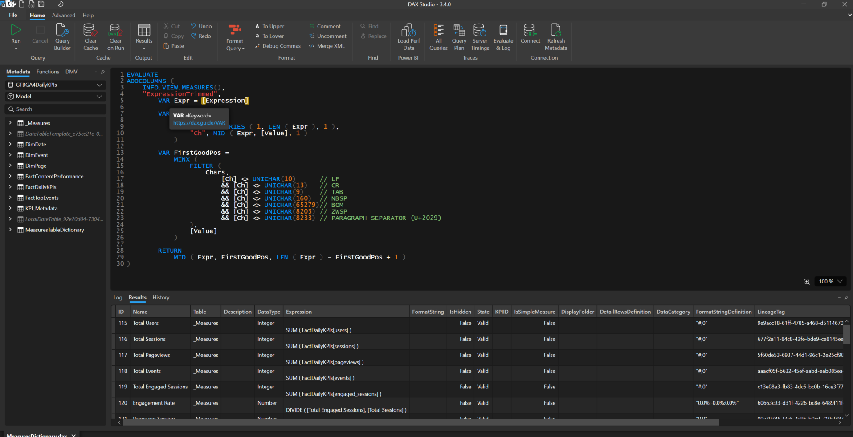

M
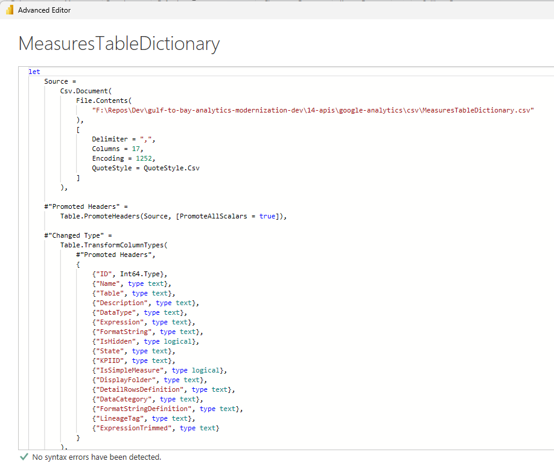

Part II — Data Journey
GA4 > SQL Server Medallion > Power BI

GA4 Source
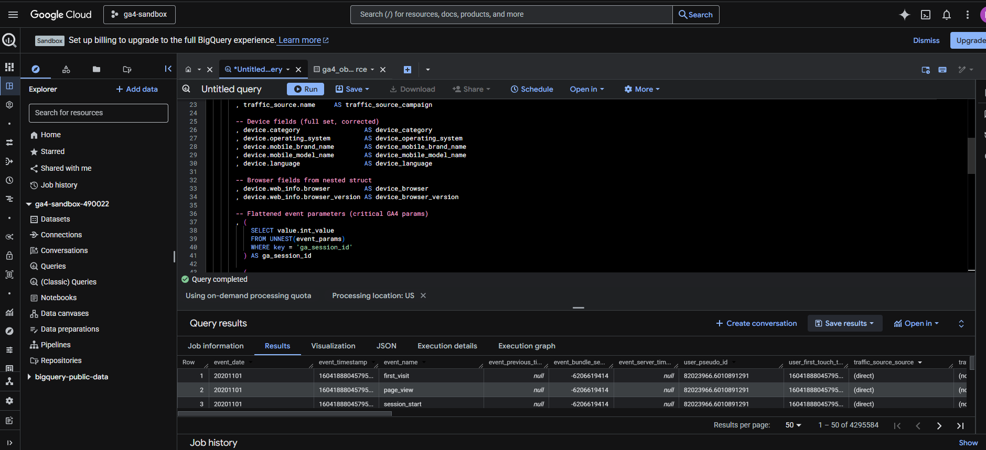

Raw web analytics data is exported from Google Analytics 4 (GA4), including:
- Events (page_view, user_engagement, scroll, view_item, etc.)
- Page locations (URLs)
- User/session identifiers
- Engagement flags

Bronze — Raw Ingestion (SQL Server)
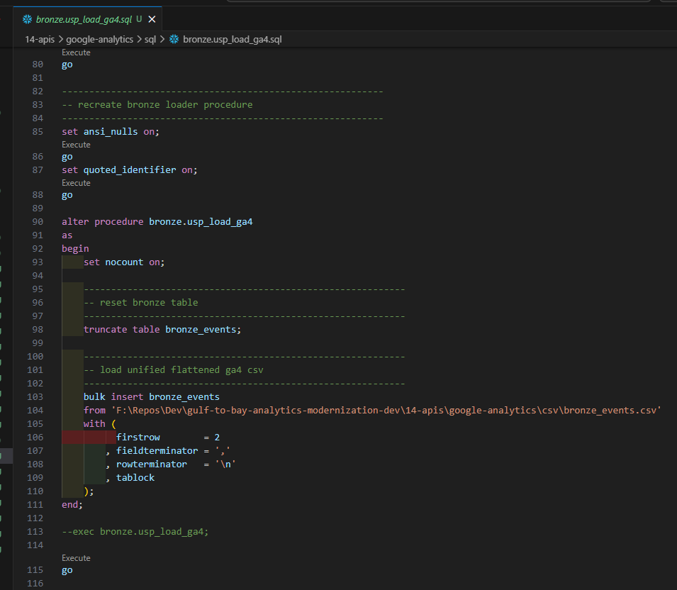

The Bronze layer in SQL Server stores GA4 exports as-is:
- No transformations
- No type coercion
- No business logic
This preserves lineage and provides a faithful copy of the GA4 event stream.

Silver — Transformation Layer
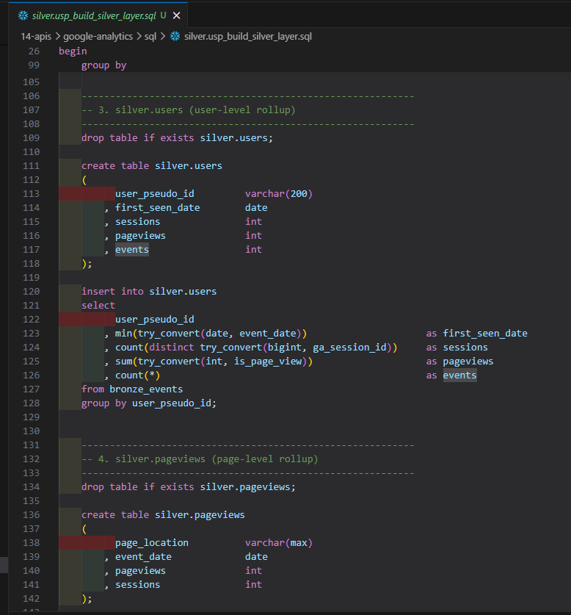

The Silver layer applies:
- Data type normalization (dates, numerics, booleans)
- Column renaming and standardization
- Null handling and basic data quality rules
- Session and pageview shaping (e.g., silver.events, silver.sessions, silver.pageviews)
This layer produces clean, analytics-ready tables that still reflect the underlying GA4 grain.
Gold — Modeling Layer
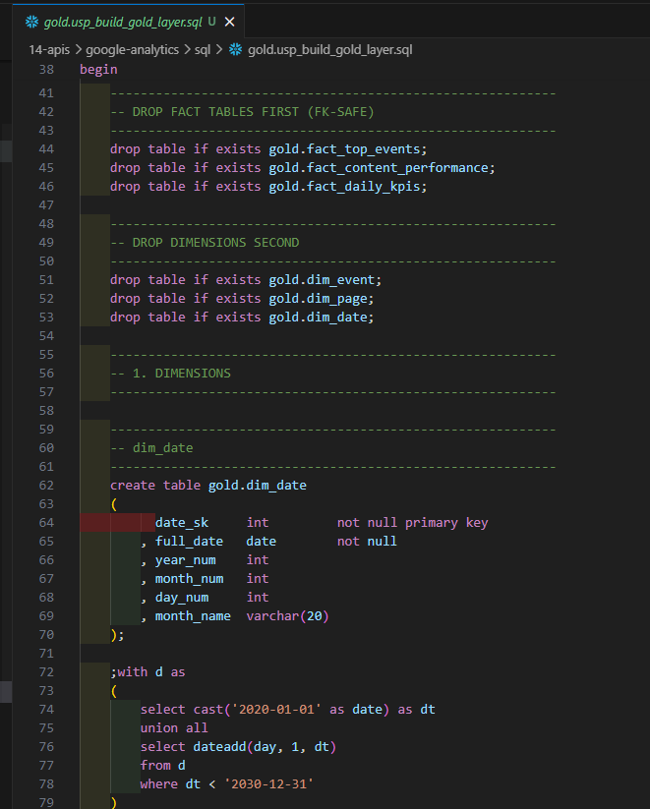

The Gold layer is optimized for Power BI and semantic modeling:
- Dimensions:
  - gold.dim_date
  - gold.dim_page (with enriched page hierarchy, page group, page type, product/category semantics)
  - gold.dim_event
- Facts:
- gold.fact_daily_kpis (users, sessions, pageviews, events, engaged sessions)
- gold.fact_content_performance (pageviews and sessions by page and date)
- gold.fact_top_events (event counts and users by event)
Reusable stored procedures support:
- Silver > Gold transformations
- Page hierarchy parsing and classification
- KPI aggregation
- View creation for semantic consumption

Semantic Views
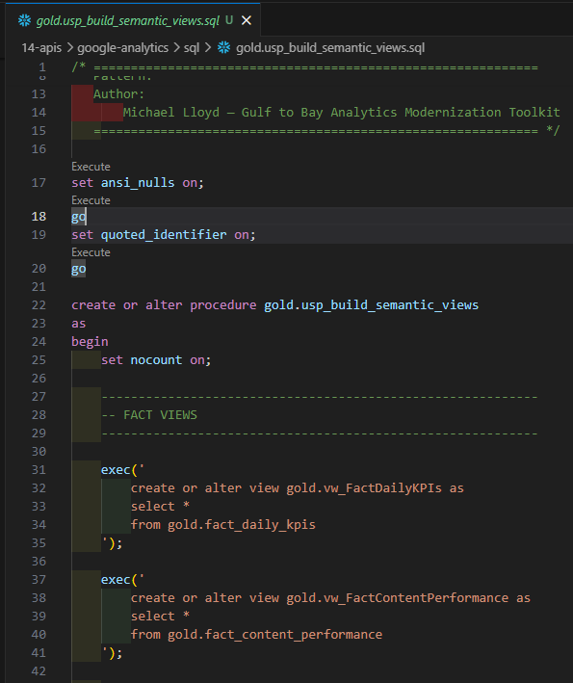

Thin views expose the Gold layer to Power BI:
- gold.vw_FactDailyKPIs
- gold.vw_FactContentPerformance
- gold.vw_FactTopEvents
- gold.vw_DimDate
- gold.vw_DimEvent
- gold.vw_DimPage
These views are intentionally shaped for a star schema and stable Power BI consumption.

Measures Dictionary Extraction (DAX Studio)
Using DAX Studio, a query (same pattern as last time) is executed to extract:
- Measure names
- DAX expressions
- Format strings
- Display folders
This output is loaded via Power Query (M) into a dedicated Measures Dictionary table, which powers the Measures Dictionary page.

Power BI Service & Power Automate
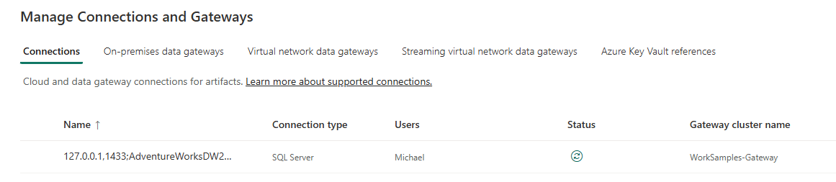

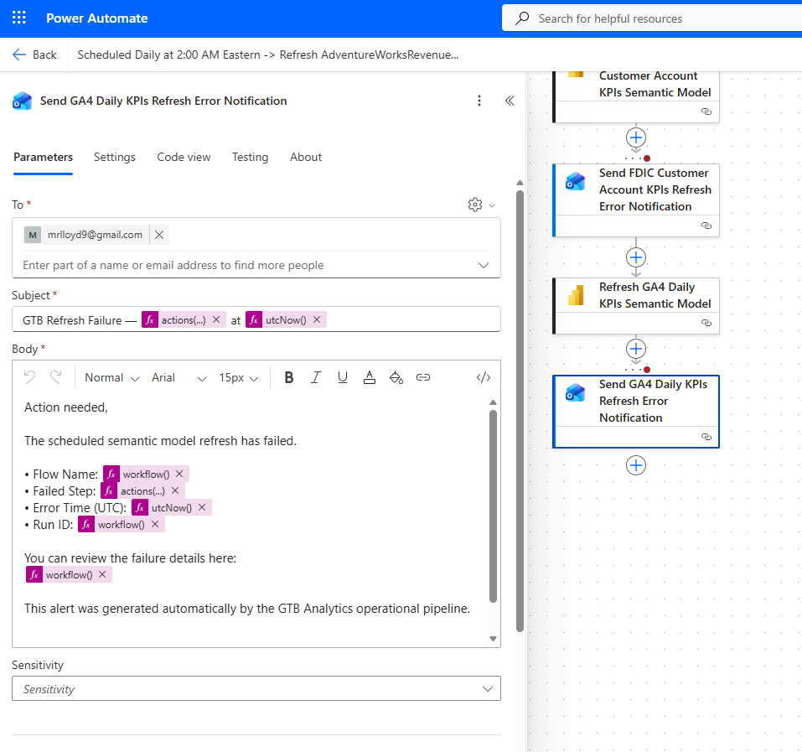

The GA4 Daily KPIs report is published to the Power BI Service for centralized access.
Key service-side features:
- Scheduled refresh using Power Automate and/or the same refresh pattern as the prior project
- Dataset settings configured for credentials and privacy levels
- Workspace permissions aligned to least-privilege access
- Versioning handled through dataset history

